Firmware Upgrade Process for P24h-30
Firmware Update Application
- PC/NB connect to monitor with USB-C.
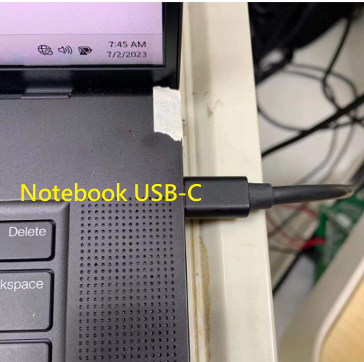
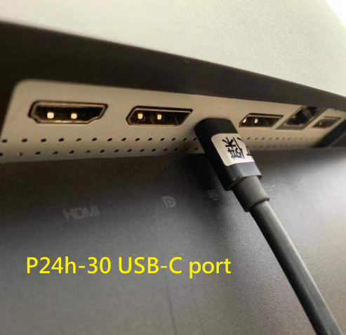

- P24h-30 open the folder “P24h-30_FW_3.5” and execute “LenovoFwUpdate.exe”, as shown below:
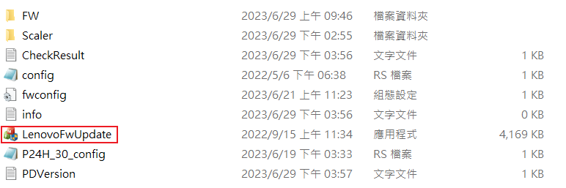

- One key update tool will show “Scaler is Out of date”, and next step is clicking “UPDATE” button.
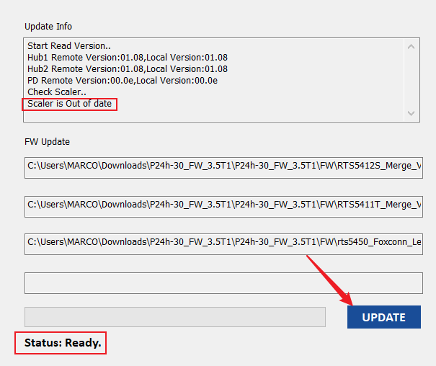

- FW update process as shown below:
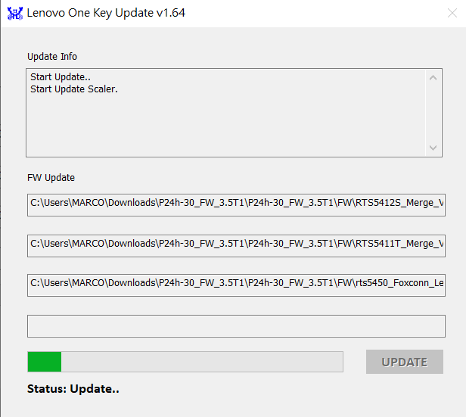

- After update successful, monitor will show the following logo and then redisplays the signal.
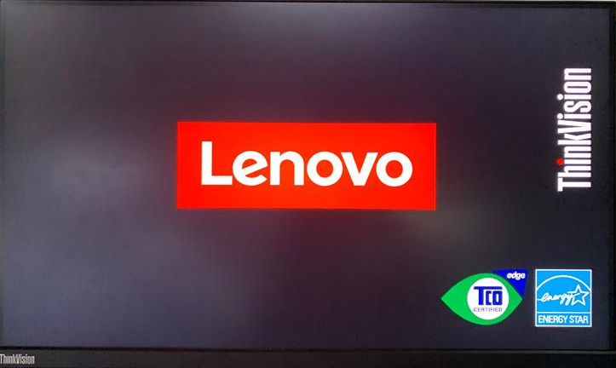

- The information on the tool will show “ALL ICs have been updated”. Then you can close the tool.
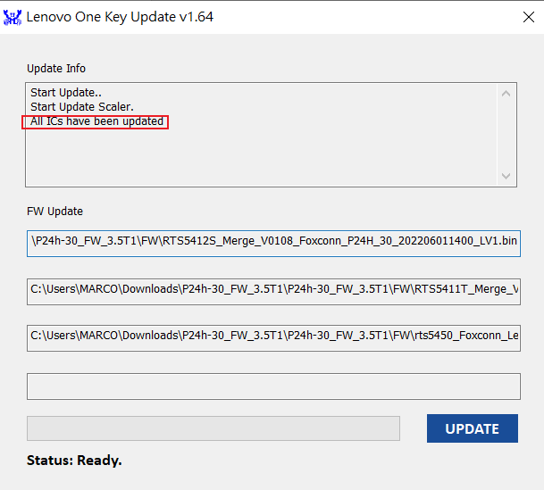

- Check the FW version in the monitor OSD menu to ensure that the update was successful.
monitor has controls at the rear which are used to adjust the display.
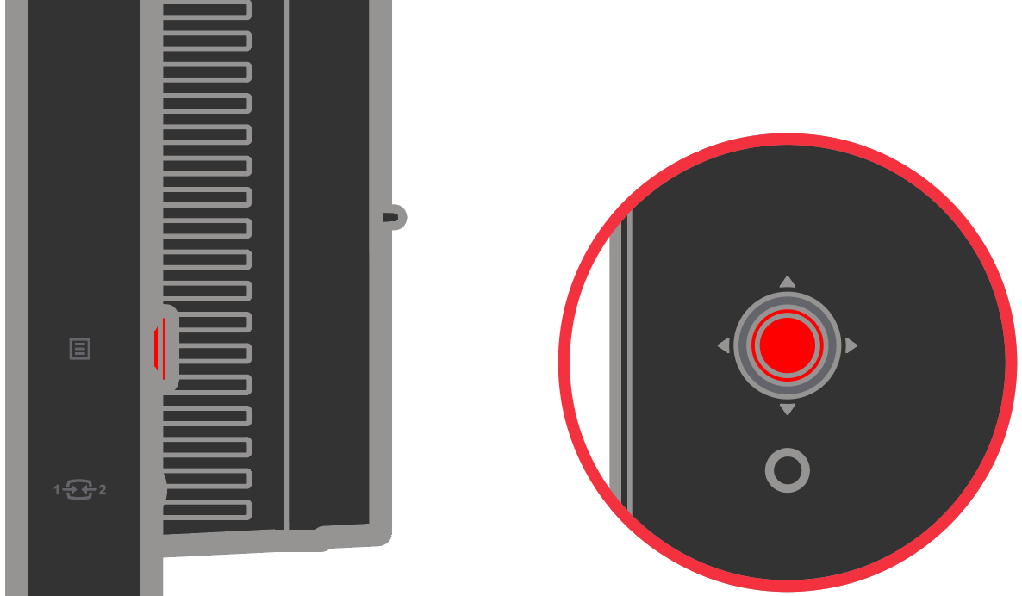
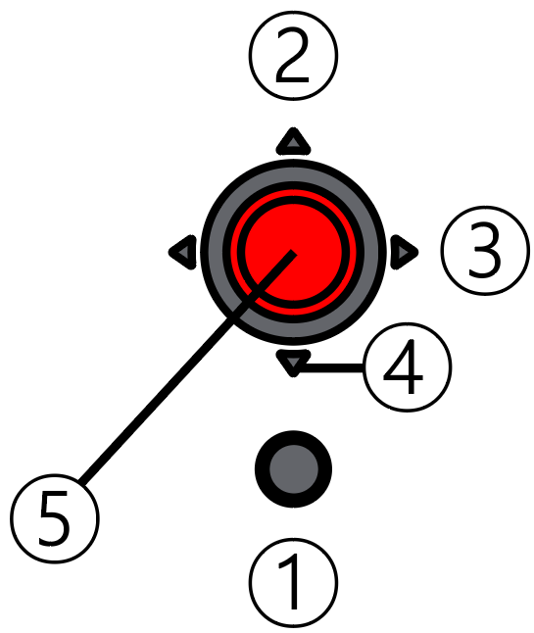
Press ⑤ to call out the OSD, then press ④ to move the cursor. When the cursor is on the “Menu settings” option press ⑤ to enter the sub-option, at this time the cursor is on Information, press ⑤ again. Then check that the version of scaler is 3.5.

