**330S KBL back flash BIOS to V23 in shell SOP**

**Step1, unzip the package(SOP_ Shell auto flash_ver23 .7z) to root directory of a udisk, then connect the udisk to the machine;**

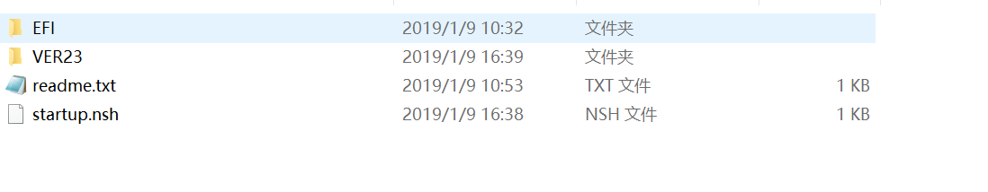

**Step2: Connector U disk to machine by USB port**

**Step3, Power on to press 'F2'to enter setup with AC power connector, set Security->Secure boot option to “disable” and press “F10”key save and exit, system will auto reboot**

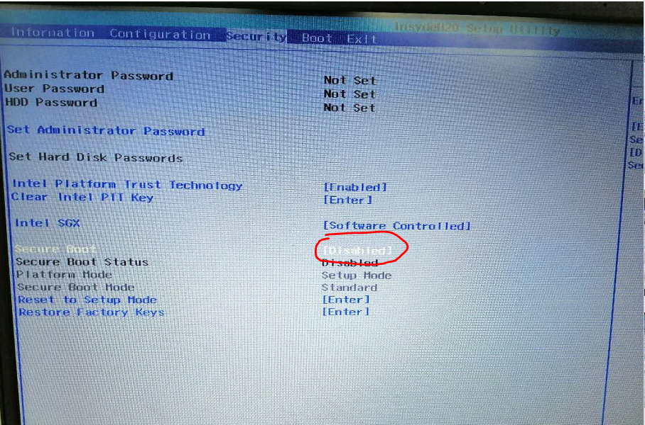

**Step5: Press “F12” key during reboot enter boot option menu and Select U disk boot (EFI USB device (xxxxx) )**

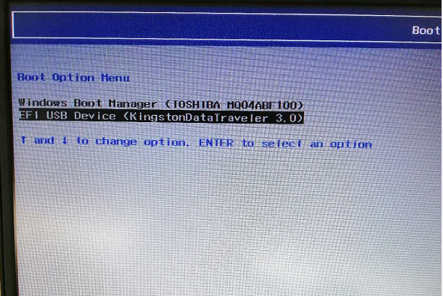

**Step6, system boot form U disk and auto flash BIOS under shell**

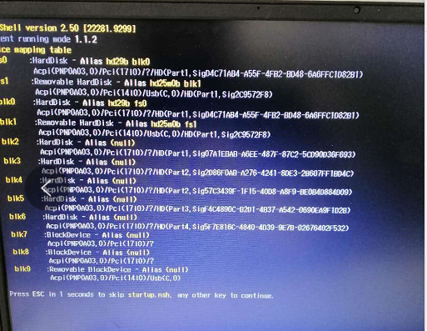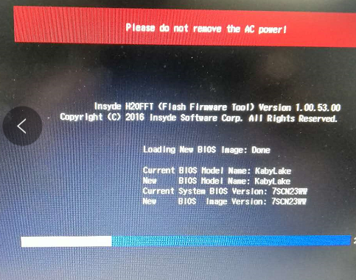

**Step7:after auto flash ,system will auto reboot**

**Step8: Power on to press 'F2'to enter setup during reboot and check BIOS version ,Make sure BIOS version is “7SCN23WW”.**

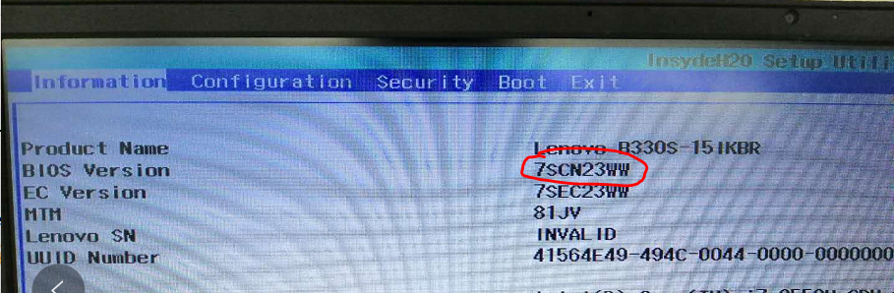

**Step9: set Security->Secure boot option to “ enable”** ,

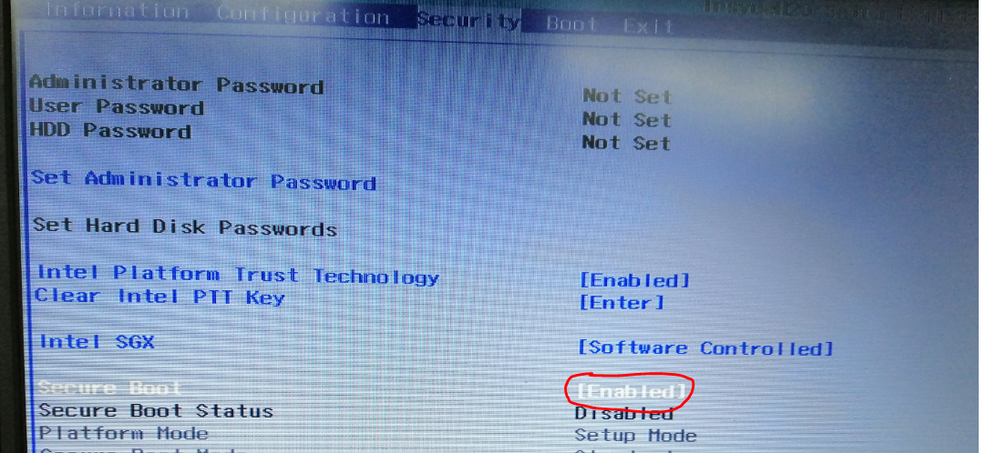

**Step10: press “F10”key save and exit (select yes) system will auto reboot ,make sure system boot to OS normally**

